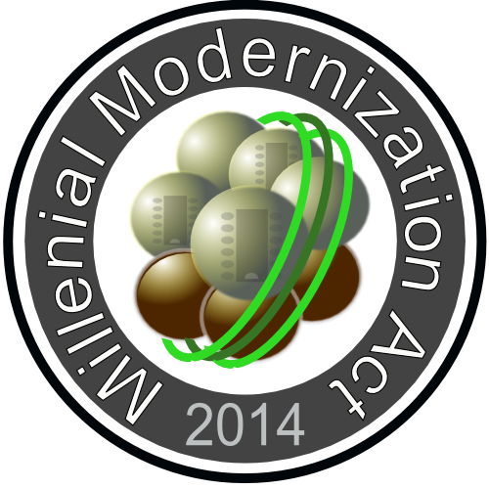

Millennial Modernization Community

This is work in progress. This notice will be removed when the document nears completion.

Millennial Modernization Community is a subset of the Millennial Modernization Act.

Introduction, Purpose:

The Millennial Modernization Community (MMC) is created with the purpose of starting an organization that ends hunger, promotes self expression, stops needless suffering and encourages peaceful co-habitation.

No child should go hungry; No person should go hungry; No human being should be without basic needs like food, facilities for fundamental hygiene, facilities for rest, and basic care for health including mental help. The Millennial Modernization Community is created to provide for this very need. The directive is simple. Any person that shows up will be fed, permitted to rest, and provided any assistance that the community can make available.

Discussion:

To this end, the Millennial Modernization Community is soliciting help in a form of donations and/or investments. a.) To create the organization, b.) To rent/lease/purchase/build facilities to render services from, c.) To employ minimal staff to run the organization, d.) To maintain accounting and reporting as needed, e.) To purchase supplies and equipment that is necessary to execute the operation.

The bulk of the help will come from existing infrastructures. There are food banks, that already cater for some of this need. They provide an essential service, however, the food banks themselves have limited resources to distribute the food. They are only open and provide services parts of the week. The true breakthrough with the Millennial Modernization Community is creating a space where any person shows up at any time, and gets his / her basic needs met.

No person left behind:

The Millennial Modernization Community promotes human equality, advances avenues to improve quality of life, secures better distribution of resources. Among many other things, it paves the path to self expression, and freedom for all of man kind. Restores the sanctity of life, peace, and the idea of non interference. Greed awakens when a person recognizes that no one helps him / her. While greed has useful implications, the greed induced by severe need is a harmful greed. The kind of greed, that makes people grab as much as they can, when opportunity arises. Erasing that kind of greed is our top priority as a human race. For future generations.

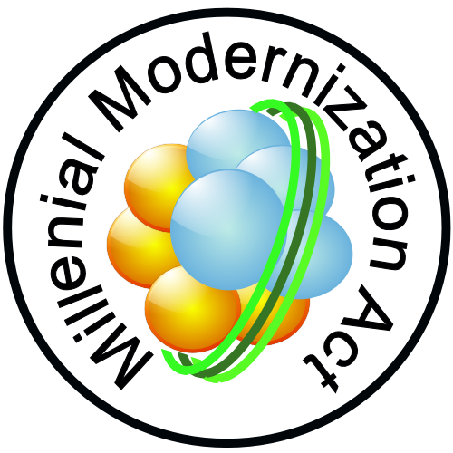

Millennial Modernization Community

Millennial Modernization Community is a subset of the Millennial Modernization Act

Taking the sting out of inequality:

In today's modern world, where resources are so plentiful, no human being should suffer from the lack of basics. Inequality does not have to hurt. While there is nothing wrong with creating abundance, and being rewarded by abundance, there is something wrong with having that abundance and having the ultimate suffering at the same time.

Initial Pilot Study, Future Vision:

The pilot study and the root location for the the initial Millennial Modernization Community is Venice, FL, USA. Because the Millennial Modernization Community addresses a fundamental human need, we anticipate, that after the pilot study at the initial location, the assistance system can be replicated easily. It may take an extended amount of time, and adaptation, but without making promises, the system has a chance to go global.

Contribution:

Initial contributors are sought for. The contribution structure will change as the organization matures, but the initial contributions can be made to Peter Glen's PayPal account at peterglen99@gmail.com. Your contributions are appreciated, and we issue a written receipt. Please give clear instructions where the receipt should go, and if you want to remain anonymous.

Distribution, access:

The Millennial Modernization Community Document is in the public domain. Unlimited and unrestricted access is granted.

Feedback, Revisions, Authenticity:

Feedback and updates to this document is encouraged. All changes should carry a clear marking of the source of origin, the intent of changes, and the description of the entity that contributed the changes. If in any doubt arises to the changes, the original is published with a verifiable signature. The fingerprint of this document is: (document signature will be provided on completion)

Please contact the author if you have any questions at peterglen99@gmail.com

Millennial Modernization Community is a subset of the Millennial Modernization Act

